Project Development Phase
Model Performance Test

Date | 02 October, 2026
Team ID | SWTID-2026-3664
Project Name | Script-Controlled ACL – Restrict Record Access Based on Field Value
Maximum Marks

Model Performance Testing:
Project team shall fill the following information in model performance testing template.
S.No. | Parameter | Values | Screenshot
 | ACL Summary | ServiceNow ACLs control record access using user roles and record field values for READ, CREATE, WRITE and DELETE operations. | 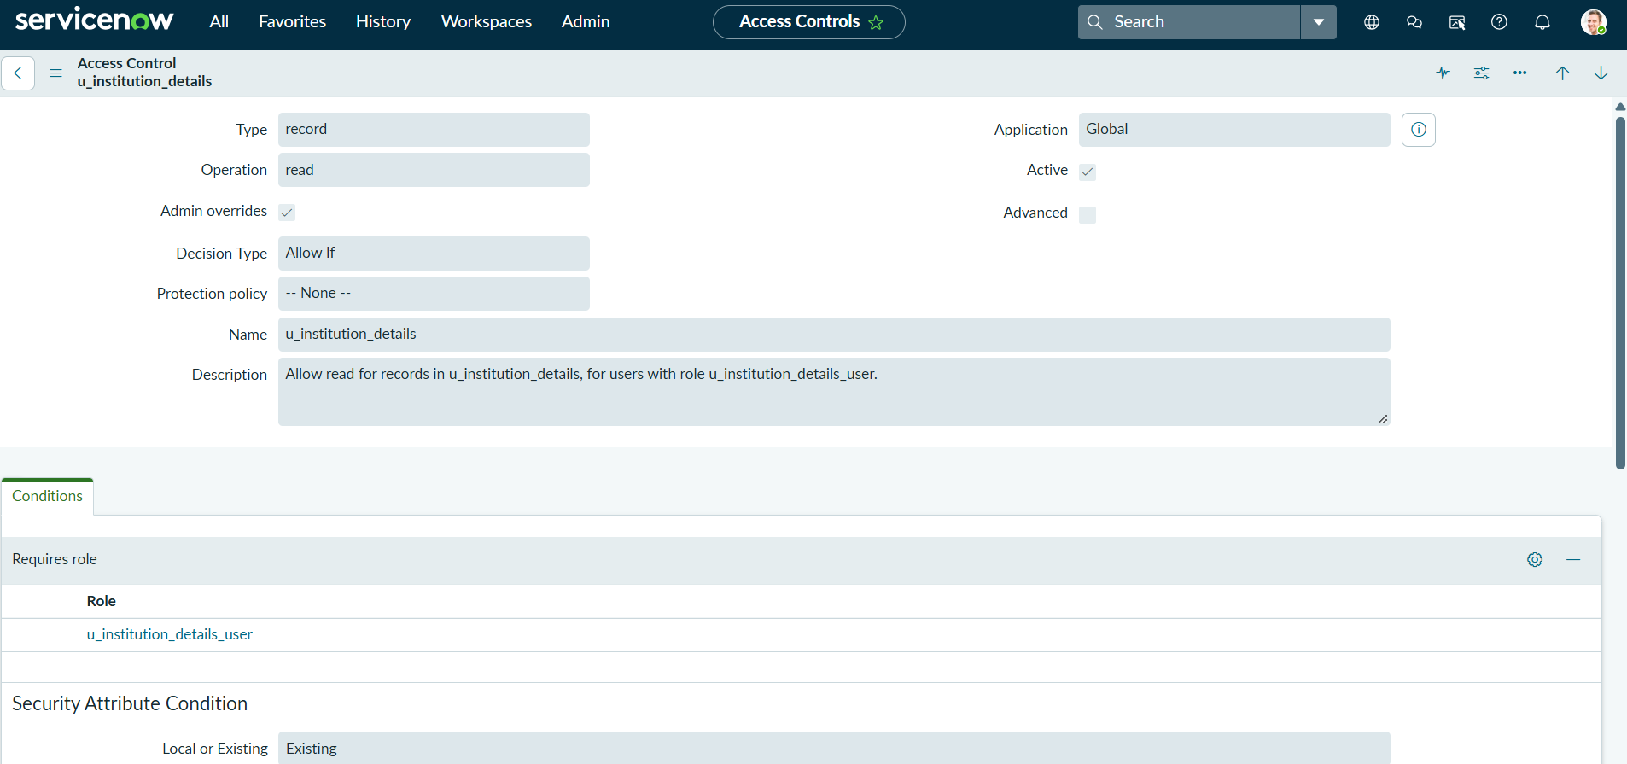
 | Access Validation | Authorized users are allowed access, while unauthorized users are denied access according to the configured ACL rules. | - 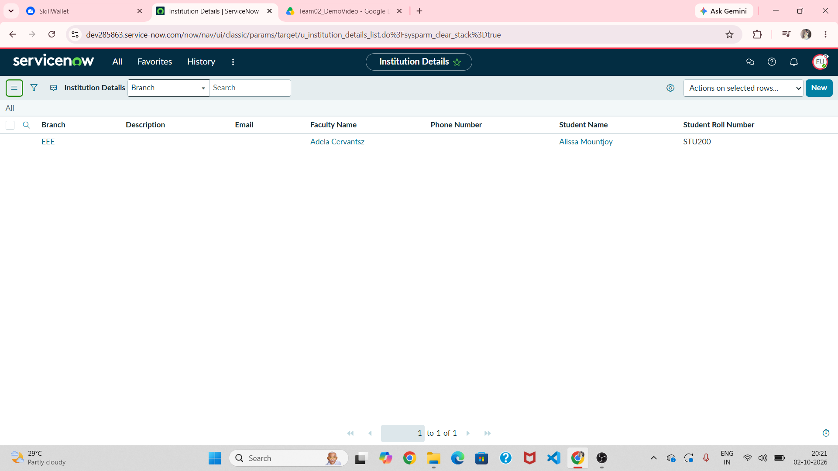
3. | Access Consistency | ACL rules consistently enforce the required access restrictions based on the user's role and record field value. | 